UG2022 & MAs Handbook

Placements at Ashoka? 3
Eligibility: 3
Timeline: 3
What is CPP? 4
Career Prep Program (CPP): 3 Mandatory Components: 5
Step 1: Update Superset profile & Send in your verification request via Duperset 5
Step 2: Enroll to Expert Resume Session 5
1. Post-verification, enroll in dummy placements cycle 5
2. Post enrolling in dummy cycle, apply for Resume Review: Mandatory Step (Set x) 6
3. Post applying for Resume Review: Mandatory Step (any set), Sign up for Expert Slot 7
Weekly Expert Sessions 7
Redlined Resume Feedback (Before Your Session) 7
Before the Session: Submit an Updated Resume 7
Missed Sessions Policy 8
Post-Session Feedback 8
Step 3: Sign-Up for Expert Interview Session 9
Student Tracker 9
Career Prep Program (CPP): Non-Mandatory Components 10
Group Sessions with CDO 10
One-on-One Sessions with CDO Experts 10
CPP Calendar & Non-Mandatory Session Schedule 10
What is Day 0 in Campus Placements? 11
1. Resume Preparation 11
Resume Building Resources 11
A. Resume Repository 11
B. Master & Variant Resume Templates 11
C. PlaceCom Resume Prompt Sheet 11
D. Office Hours with PlaceCom 12
2. Profile Verification on Superset 12
3. Application to Companies 12
4. Shortlisting and Pre-Day 0 Rounds 12
5. Day 0 12
Interview Preparation Resources for Day 0 12
A. Interview Preparation Sheet 13
B. Mentor-Mentee Program 13
What Happens After Day 0? 14
Placement Policy 2025-26 15
1. Types of Companies 15
1.1 Category 1 Company: 15
1.2 Category 2 Companies: 15
1.3 Dream attempt/company: 17
2. Pre-placement Talks (PPT) 18
3. Submission and Withdrawal of Application 19
3.1 Submission of Application 19
3.2 Withdrawal of Application 19
4. Interview Round Guidelines 21
4.1 General Guidelines for Interview 21
4.2 Final Interviews on Day Zero: 21
4.3 Multiple Offers Policy during Day Zero: 21
5. Final Offer and CTC Negotiation 22
5.1 For Category-1 Companies 22
5.2 For Category-2 Companies 22
5.3 Exception to No-Rejection Policy after Offer 22
6. Miscellaneous Rules 23
6.1 Pre-Placement Offer (PPO) 23
6.2 Higher Education Plans 23
6.3 Semester Abroad 23
6.4 Lying/Exaggerating/Misrepresenting information 23
6.5 Communication & Resources 24
6.6 Policy Violations 24
7. Deferred Placement Policy 25
Some More Important Resources 26
● Placement History & Company Data: 26
● MasterDrive (One-Stop Solution) 26
Frequently Asked Questions (FAQs) 27

Placements at Ashoka?

Eligibility:
This policy applies exclusively to students from the graduating batches of 2026, including:
- 4th Year Undergraduate Students
- Master’s Students
- Young India Fellowship (YIF) Scholars
The Career Development Office (CDO) and PlaceCom will kick off the placement season by circulating a mandatory registration form. This form helps us gather important information such as:
- Your dream companies
- Preparation needs
- Targeted sectors, and more.
This data helps us plan effective outreach and design support tailored to your goals. Most importantly, it allows us to begin with the Career Prep Program (CPP) — the first step in the placement process, focused entirely on equipping you for the upcoming season. All eligible students must have successfully completed the 3 mandatory steps of Career Preparatory Programme (CPP) for the academic year 2025–26 prior to participating in the placement process. To know more about CPP, go to page 4.

What is CPP?
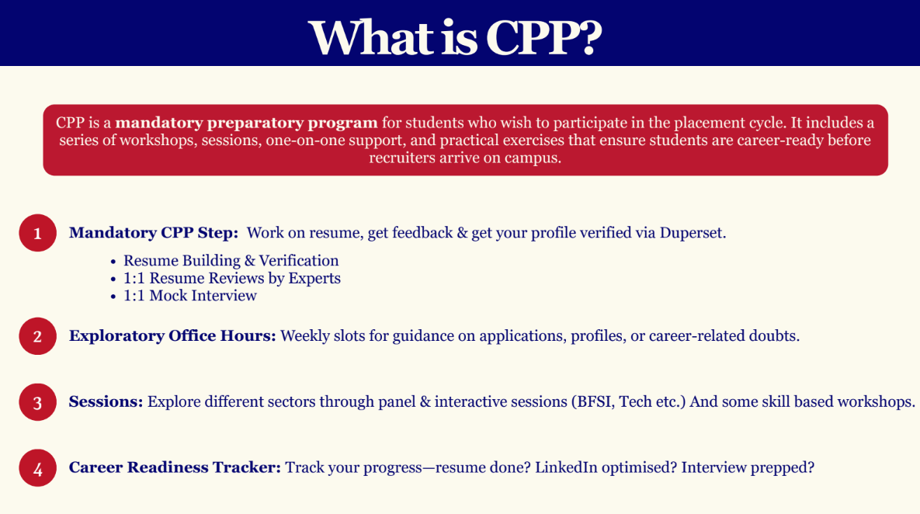
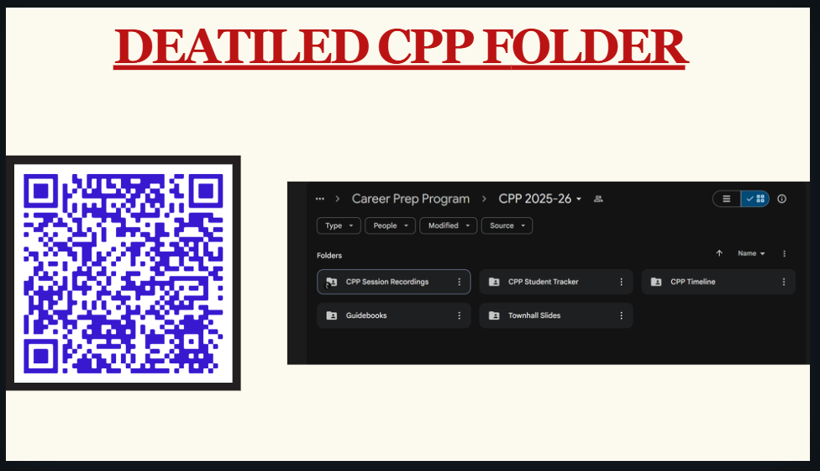

Career Prep Program (CPP): 3 Mandatory Components:

Step 1: Update Superset profile & Send in your verification request via Duperset
Follow the Superset Verifications Guide: PlaceCom_Superset Verification Guidelines

- You make all edits to your profile and follow the basic resume guidelines.
- Make sure your passout batch is 2026 on Superset.

Step 2: Enroll to Expert Resume Session
Enrolling to Expert resume session also has 3 steps further:-

Post-verification, enroll in dummy placements cycle
Log into your account → go to ‘My Profile’ → ‘Basic Details’ → scroll down and you will see ‘Placement Enrollments’ → Click on the enroll button located on the right side of ‘Dummy Placement Cycle 2025-26’.
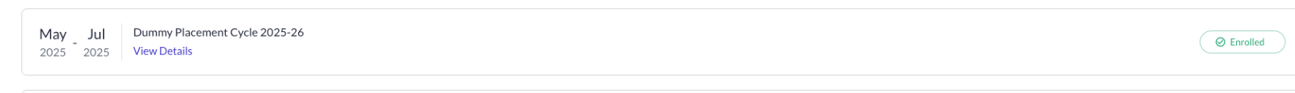

Once you enroll, you will see screen as shown below:
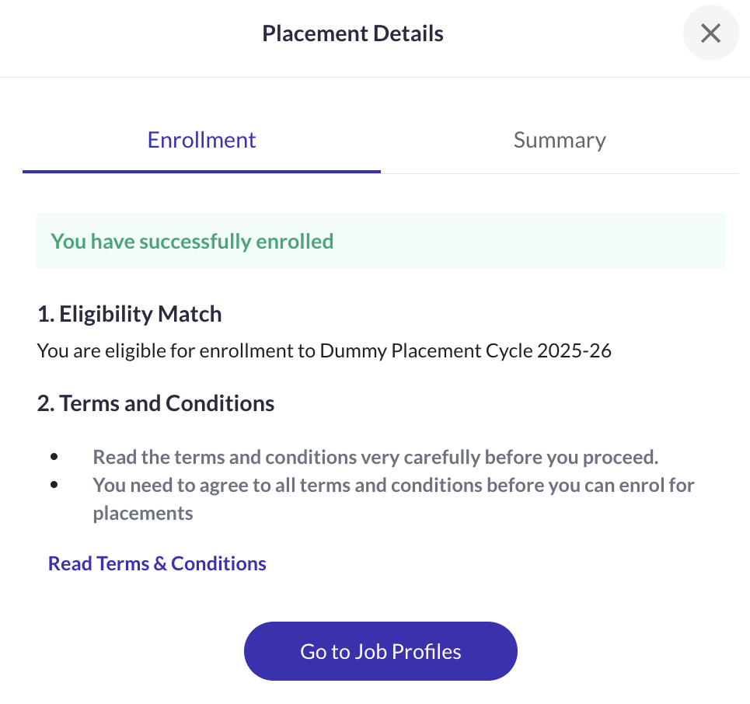

Post enrolling in dummy cycle, apply for Resume Review: Mandatory Step (Set x)
Log into your account → go to ‘Job Profiles’ → ‘Basic Details’ → click on ‘Resume Review: Mandatory Step [Set 1]’ → Click on ‘Apply’ that is on the top right corner of the ‘Resume Review: Mandatory Step [Step 1/2/3]’ Job Profile.

Please note: There are multiple sets opened for ‘Resume Review: Mandatory Step’. As given below:-

Set | Start-End Date | Eligible
‘Resume Review: Mandatory Step [Set 1] | 1st June - 25th June | - Undergraduate students from the UG 2022 intake  - Late graduates  - Master’s students graduating in 2026
‘Resume Review: Mandatory Step [Set 2] | 21st July - 30th July | - Undergraduate students from the UG 2022 intake  - Late graduates  - Master’s students graduating in 2026
‘Resume Review: Mandatory Step [Set 3] | 1st Aug - 5th Aug | - Ashoka Fellows graduating in 2026 ONLY!

Post applying for Resume Review: Mandatory Step (any set), Sign up for Expert Slot
Once you apply for resume review on Superset, you’ll receive access to a Google Sheet on your email containing time slots with external experts. These are professionals you can meet with to review and refine your resume.

Weekly Expert Sessions
- Expert resume sessions will be conducted on weekends.
- The sign-up sheet for each weekend opens every Wednesday at 4:00 PM of the previous week and closes by Thursday EOD of the previous week.
  - For example, slots for 16th & 17th August will open on 6th August (Wednesday) and close on 7th August (Thursday).

Redlined Resume Feedback (Before Your Session)
- After applying on Superset, you’ll receive a redlined version of your resume (with comments and suggestions from your assigned expert) in your email. This may happen even before you sign up for a specific time slot.
- This redlined resume is based on the resume you submitted while applying on Superset in Step 2.2.

Before the Session: Submit an Updated Resume
You are expected to revise your resume based on the redline comments. Then, go back to the sign-up sheet you received and upload your updated resume (PDF) to Google form on the slot sheet.
The updated resume must be generated via Superset → Resume Builder. No re-verification is needed, just download the new version and upload it to Drive.
Deadline to submit the revised resume link: Wednesday EOD of the same week as your session.
(E.g., for 16th–17th August sessions, submit by 13th August)
Session Day
- You will receive a reminder email 2–3 hours before your session.
- The link to the session will be on the slot sheet 12 hours before your session.
- Please ensure you attend the session on time using the credentials provided.

Missed Sessions Policy
If you miss your scheduled session or fail to show up:
- Your ID will be blocked for 2 weeks
- You will not be allowed to book any resume review sessions during this period

Post-Session Feedback
After your expert session, you’ll receive a feedback form. Kindly fill it out; it helps us improve future sessions and offerings.
Guidelines to Fill the Expert Resume Sign-up Sheet

COLUMN | What to Fill | Notes
F (MANDATORY)  IMP: Used for sending session reminders. | Your Name (Name Chip) | Click on the name smart chip, start typing your name (your Ashoka email should pop up).  Do not manually type your name or email ID.
G (MANDATORY) | Batch | This will be auto-filled once the name chip is selected correctly.
H (MANDATORY) | Phone Numbers | Required for quick communication.
I (MANDATORY) | Major | Enter your declared major.
J (Suggested) | Student Expectations | Share any specific areas you want feedback on (e.g., formatting, content, role/sector specific etc.).
O  (IMP MANDATORY) | Latest Resume | Upload your latest resume to your Ashoka Google Drive  Please ensure that you give the PDF files access to @priyanka.laishram@mbatrek.com, connect.cdo@ashoka.edu.in & connect.placecom@ashoka.edu.in

Step 3: Sign-Up for Expert Interview Session
Once the resume reviews are complete, you will get a sign-up google sheet for an expert interview session. Once you complete that, all mandatory steps for CPP are completed.

Student Tracker
This is your one stop destination to check what stage of the Career Prep you are at. Use this sheet to track your individual progress across all mandatory steps for the CPP (Career Preparation Programme). You can also see if you have enrolled by finding your name on this sheet.

CPP Student Tracker_2025-26.

*Please note: This tracker gets updated every Sunday EOD, after all weekly expert resume sessions conclude.

Career Prep Program (CPP): Non-Mandatory Components
While CPP has 3 mandatory steps, there are also several non-mandatory but highly recommended components designed to support your preparation further.

Group Sessions with CDO
- Held every Friday after 6:30 PM
- Conducted by CDO experts on various placement prep topics
- All sessions are recorded and accessible via this folder: CPP Session Recordings-Pre Day 0
- Strongly recommended to watch all recordings — they provide valuable preparation insights!

One-on-One Sessions with CDO Experts
If you'd like personalised career counselling/ guidance, you can also schedule 1-on-1 sessions with CDO experts.
How to Book a Slot:
- Log in to AMS
- Go to Student Support → Advising Hub: Office Hours
- From the drop-down, choose Career Prep Program
- Select a date and time that works for you
- Your slot will be auto-added to your calendar
A few quick notes:
- These Office Hours are distinct from the Career Development Program and Postgraduate Office sessions on AMS
- They are not part of the mandatory resume review or mock interviews required for placement enrollment.
- Attendance is not mandatory—but highly encouraged!

CPP Calendar & Non-Mandatory Session Schedule
To view the full CPP calendar, including upcoming group sessions and other events, check this link: CPP Calendar_2025-26.xlsx

What is Day 0 in Campus Placements?
Day 0 is a key and 1st milestone in the placement cycle of the academic year. It is part of phase 1,where the first set of organisations begin sharing their job descriptions (JDs) around late August to early September. While different companies may run their initial processes on varying timelines, final interviews for many are scheduled on Day 0.
This day is particularly significant because it’s when several premier recruiters conduct their final rounds and make offers—often setting the tone for the rest of the placement season.
Once CPP is completed and you are enrolled into the placement cycle, the placement process unfolds in multiple stages, Let’s walk through it from the beginning assuming that company X comes for hiring:

1. Resume Preparation
Before applying to any company, you must create a tailored resume. Use the resources below to guide your process:

Resume Building Resources
Kickstart your placement prep with these essential resources to help you craft an impactful resume. These tools will help you understand formatting and content and how to tailor your resume to different roles and industries.

Resume Repository
- Explore resumes of previously placed students across sectors like consulting, finance, social impact, and more. Use these as reference points while crafting your own resume.
- Link to Resume Repository: PlaceCom_Resume Repository

Master & Variant Resume Templates
- Use these to structure your own résumé according to the CDO guidelines.
Includes:
- Master Resume Template: General template used across sectors
- Variant Resume Examples: Sample customizations for different job profiles
- Link to the Template: PlaceCom_Master VS Variant Resume Making.pdf

PlaceCom Resume Prompt Sheet
- A guided worksheet to help you brainstorm and articulate your achievements, responsibilities, and impact across internships, projects, and leadership roles.
- Link to the prompt sheet: PlaceCom_Prompt Sheet

Office Hours with PlaceCom
- Book a 15-minute one-on-one slot with a PlaceCom member to get feedback on your draft before submitting to expert sessions.
- Link for booking a session: PlaceCom_Office Hours

2. Profile Verification on Superset
Once your resume is ready, submit it and get your profile verified via Duperset.

3. Application to Companies
Apply to company-specific job profiles using the variant resume tailored for that role on Superset by submitting your resume & other details required.

4. Shortlisting and Pre-Day 0 Rounds
If shortlisted:
- You may be invited for technical tests, aptitude rounds, or interviews (this varies by company).
- Some rounds might be online, monitored, or timed submissions.
- These preliminary rounds typically happen before Day 0 — in late August or early-mid September.

5. Day 0
Day 0 refers to a designated 2-day window when marquee firms (top recruiters across sectors) conduct their final interview rounds, often on campus.
- Usually scheduled for the end of September or start of October.
- If selected, you’ll know your result on the same day.
- This marks the conclusion of the initial hiring phase.

Interview Preparation Resources for Day 0
Prepare confidently for your interviews with curated, insider-led resources. These tools feature real questions asked by recruiters and tips shared by selected students to help you build confidence and clarity.

Interview Preparation Sheet
  - Contains actual interview questions asked by recruiters from companies such as BCG, Accenture, Deloitte, DE Shaw, TCF, etc. A great resource to understand what recruiters look for and tailor your prep accordingly.
  - Link to Interview Prep Sheet: PlaceCom_Interview Preparation Sheet'25

Mentor-Mentee Program
  - Navigating academics and career choices can be challenging—but you don’t have to do it alone.
  - This initiative pairs current students with recent Ashoka alumni working at top firms like BCG, EY, Deloitte, Dalberg, and more. We will be offering one-on-one mentorship to help you explore career options, seek advice on placements/internships, and gain professional insights.
  - Link to Mentor-Mentee Program sign-up sheet: Application Form. This is phase 1 of the program, we will be having multiple phases with more mentors soon!

What Happens After Day 0?
- The process moves into Phase 1, then Phase 2, and Phase 3 — each bringing new companies to campus.
- These phases do not indicate any hierarchy; they exist for administrative ease and scheduling.

Timeline:
The placement process will be broadly conducted in four phases, each designed to streamline recruitment and maximize opportunities for students.
- Career Preparation Program (July onwards)
  - Foundational prep sessions and training begin.
- Day Zero (October)
  - First major set of company interactions and applications.
- Phase 1 (October – December)
  - Active hiring period with multiple companies visiting campus.
- Phase 2 (January – March)
  - Continued hiring with new sets of roles and companies.
- Phase 3 (April – May)
  - Final wave of hiring before the cycle closes.
- Joining Dates (Mid-June / July)

Most students start their roles around this time, post graduation.

Placement Policy 2025-26

1. Types of Companies

1.1 Category 1 Company:
A Category 1 company is a company that must meet at least one of the following conditions:
- Features in the Fortune Global 500, Fortune India 100, GPTW 100, Fortune GPTW 100, or GPTW Global 25 lists.
- Is a Unicorn or appears in the Sector Wise Top 10 list.
- It is recognized as a marquee or Day 0 organization.
- Is in patronage with the CDO.
- It offers a CTC higher than the average of the sector in the previous placement cycle.
Offer Policy for Category-1
- If a candidate receives a placement from a Category 1 company, they are out of the placement cycle due to the one offer policy.

1.2 Category 2 Companies:
A Category 2 company is any organization that does not meet the criteria for Category 1 and will automatically be classified as Category 2.
Offer Policy for Category-2
- If a student receives a placement offer from a Category 2 organization (as communicated by the Career Development Office or Placement Committee), they become eligible for four (4) additional placement attempts. These four attempts can be used in two ways:
  - Ongoing Processes: Applying to companies for which the student had already submitted applications before receiving the Category 2 offer.
  - Future Processes: Applying to companies whose Job Descriptions (JDs) are released on Superset after the Category 2 offer is received, or saving attempts for yet-to-come companies. In the latter case, it will be called an “undecided” attempt.
- If a student wishes to avail 4 additional attempts, they must notify the CDO and PlaceCom of their decision within 24 hours of receiving the Category 2 offer.
- This must be done via email and include a 200-word cover note explaining why they wish to continue participating in the placement process or target specific companies.
Failure to comply within the 24-hour window will result in forfeiture of all remaining attempts.
- Students may choose to hold back a certain number of their four additional attempts as “undecided” for use with future companies, as mentioned above. However, when a student decides to apply to a company they had previously tagged as “undecided” in a 200-word cover note, they must immediately inform both the CDO and the designated PlaceCom PoC.
Failure to notify will result in the automatic withdrawal of the application.
- A student who has received a Category 2 offer may hold a maximum of two offers:
  - The initial Category 2 offer.
  - The first offer received from the four additional attempts (regardless of the company category or timing) will be considered the final offer, and the student shall lose the initial offer.

1.3 Dream attempt/company:
CDO will define certain organizations as “dream” based on brand, relationship, and CTC. All the students enrolled in the placement cycle will get one attempt to apply for the dream company.*
Offer Policy for Dream Company
- Maximum 2 offers, irrespective of the number of attempts
- In case a student exercises the dream option and converts it, the second offer will be their default choice, and the first offer will automatically be considered rejected.

* Students’ eligibility is up to CDO’s discretion. Students who reject an offer are not eligible for a dream attempt.

2. Pre-placement Talks (PPT)
- A pre-placement talk is conducted by the company participating in the placement process.
- It generally includes a detailed presentation that provides applicants with an overview of the company, its policies, hierarchy, recruitment process, career growth, job location, positions, and salaries offered.
- This is a two-way discussion, where students are encouraged to clarify their doubts or discuss anything related to the company or the profile.
- It is mandatory to attend the PPT (with videos on) of the company you are applying to; non-attendance may lead to a penalty (check 7.5). If applications for a company open after the PPT, only students who have attended the PPT will be eligible to apply.
- PPT generally happens before applications close, so that students can understand the company; however, sometimes, it is also conducted after the applications are closed. In such cases, students get to withdraw their application within a given period if they want to (check 3.2).
- Students need to attend for at least 80% of the entire duration of the workshop/ discussions / PPT, etc., to be marked present.
- For virtual events like PPTs, all students are required to keep their camera on, and all queries/comments during the PPTs must be professional and respectful.
- All questions to recruiters outside of the PPT must be routed through the CDO/ PlaceCom, and direct communication with recruiters should be done only after written approval from the CDO/ PlaceCom, or else a penalty applies (check 7.5).
- Any query regarding the CTC breakup/compensation structure should be clarified in the PPT (or relayed through the PlaceCom Coordinator in case no PPT is scheduled) at the time of application submission.

3. Submission and Withdrawal of Application

3.1 Submission of Application
- A student who is still in the placement process is allowed to apply for all the jobs that come on campus, both social and corporate. Unless the job profile posted on Superset states otherwise (according to the recruiter’s preference).
- All resumes that are submitted for applications must be strictly a one-page Ashoka resume format. Resumes not in line with the guidelines will be rejected before being sent to the recruiter.
- All applications are promptly shared with recruiters, and requests for deadline extensions won’t be considered. Some applications might be more detailed, so kindly plan and apply accordingly.
- Carefully read the entirety of the Job Description and other details (shared via Superset, email, or during PPT) regarding the job application. Mandatory requirements for successful completion of applications can be communicated via any of these channels, and if they are missed, your application will be removed from the applicant list.
- In case of any doubts, please direct all queries to the company's PlaceCom Coordinator before applying to avoid any misinterpretations.

3.2 Withdrawal of Application
No application may be withdrawn after the deadline for application submission has passed. However, there are a few exceptions:
- Withdrawal of the application from Superset will be permitted for companies that conduct a PPT after the closing of applications. Students can withdraw their application until 30 minutes after the PPT has been delivered. If the PPT is for the shortlisted candidates only, they may not be allowed to withdraw their application.
- If any changes occur in the job description due to a change in the organization's recruitment needs, the candidates will be able to withdraw their application mid-way without incurring any penalty/start afresh.
In any other case, if you decide to withdraw from the placement process or withdraw after closing of applications, you must contact the PlaceCom POC for the company, and, if required, the CDO.

4. Interview Round Guidelines

4.1 General Guidelines for Interview
Aspect | Guideline
Non-Attendance | If the student qualifies through to the interview round and does not attend it, it will lead to a heavy penalty (check 7.5).
Late Arrival | Late Arrival is treated as non-attendance. Students are expected to be prepared at least 15 minutes before their scheduled interview slot
Dress Code | Students must wear business formal attire only during all processes.

4.2 Final Interviews on Day Zero:
- Students shortlisted for the final round of interviews, which will be occurring on Day Zero, will be receiving further instructions from the PlaceCom and the CDO regarding logistical details such as time slots, venue details, among others.

4.3 Multiple Offers Policy during Day Zero:
- Students shortlisted for multiple organizations will receive a Preference List (form to indicate their preference for the organizations shortlisted).
- Students will be required to submit their preferences before the final interviews, and the timeline will be communicated by PlaceCom and CDO accordingly.
- If an offer is received from more than one organization (for students being shortlisted for multiple organizations for final interviews), the final offer will be processed as per the preference of the student, indicated in the preference list.

5. Final Offer and CTC Negotiation
CDO follows a No-Rejection Policy, meaning that once a student receives an offer, it is automatically accepted. The policy applies to both Category-1 and Category-2 companies, with the following guidelines:

5.1 For Category-1 Companies
- Once a student receives an offer from a Category-1 company, they are blocked from participating in the rest of the placement cycle.
- However, students are allowed to attempt a Dream Company interview even after receiving a Category-1 offer.
  - If selected by the Dream Company, the Dream Offer will replace the Category-1 offer, which is then considered rejected.

5.2 For Category-2 Companies
- An offer from a Category-2 company is also automatically accepted.
- After this, the student is allowed up to 4 additional attempts.
  - If the student receives a new offer during any of these attempts, the previous Category-2 offer is automatically rejected, and the new offer is accepted.
  - Only the first offer received out of the 4 attempts will be considered for replacement.
Reiterating that a student can receive a maximum of 2 offers throughout the placement cycle as described above.

5.3 Exception to No-Rejection Policy after Offer
- If a company modifies its CTC from what was originally communicated during the PPT/ in the JD, the student is allowed to reject the offer w/o any penalty.

6. Miscellaneous Rules

6.1 Pre-Placement Offer (PPO)
- A PPO will be considered as a job offer through campus placements:
- Accepting a PPO is indicative of the student being considered as per Categories 1 and 2 of the Placement Policy, and next steps will be communicated accordingly.
- Declining a PPO would be considered on a case-by-case basis, where the reasons would be carefully evaluated by the CDO/ PlaceCom before reaching a decision.
- The CDO shall always be kept in the loop in all official communication with the company's Point of Contact. This applies even in cases of direct communication with the recruiter.

6.2 Higher Education Plans
- In case of higher education plans, SGOs (Self-Generated Offers), you are expected to have complete transparency before, during, and after the interview. You must inform the CDO in advance about the same.
- The student needs to inform CDO about their higher education plan every time they apply to a new company.

6.3 Semester Abroad
- If a student is attending a Semester abroad, CDO will request the recruiter to accommodate the student however, the decision lies solely with the recruiter.
- The student needs to inform CDO about their semester abroad plans every time they apply to a new company.

6.4 Lying/Exaggerating/Misrepresenting information
- If a student is found to be fabricating information, faking achievements, exaggerating facts, and indulging in other such dishonesty on their resume, cover letters, and interviews, they will be blocked for the entire placement cycle.
- The PlaceCom/CDO may also conduct randomized fact checks at various stages of the Placement process.

6.5 Communication & Resources
- Keeping the students’ interest in mind, the CDO will be sending out Superset undertakings/surveys from time to time. Students should promptly fill these out to communicate their interest in the campus placements and ensure they enroll in the placement cycle.
- Students are encouraged to seek guidance from the CDO and access the placement preparation resources/workshops being offered by the CDO and Placement Committee (PlaceCom). You can check out PlaceCom MasterDrive here.

6.6 Policy Violations
Policy violation | Penalty
The resume is not in the Ashoka format, or it doesn’t follow the standard guidelines | Not eligible to sit in the CDO processes
Lying, Exaggerating, and/or Misrepresenting the information | Blocked for the entire placement cycle
Non-Attendance - PPT | 10 Days block
Non-Attendance/Participation/Late Arrival /Late Submission  In the first Interview/ Test/ Assignment | 15 Days block
Misconduct with Ashoka staff/ recruiters* | 20 - 30 Days Block

7. Deferred Placement Policy
This policy aims to support Ashoka University graduates who aspire to become entrepreneurs by offering a safety net in case their venture fails or if they choose to leave their startup venture. All graduates are eligible for this policy if they become entrepreneurs. They can avail support under this policy for a maximum of 2 years from their graduation date.
- Final-year students can choose to opt out of the placement process for that year by participating in the 'deferred placement program'.
- The decision to join the deferred placement program must be made before the beginning of the Day Zero placement process.
- The deferred placement program is exclusively available to graduating students who become entrepreneurs by starting their own venture or joining a startup as a co-founder.
- Graduating students need to provide proof of their startup.
- If a graduate, after opting for the deferred placement policy and starting their own venture, decides to discontinue their association with the startup, they can approach the CDO to be included in the next placement cycle.
- This option is available to the graduate after one year of the date of graduation and for up to 2 years.
- The graduate must provide proof of their dissociation from the startup if they wish to sit in the placement process.

Some More Important Resources

Placement History & Company Data:
Past company data is available here Past Recruiters Data & Analysis .

MasterDrive (One-Stop Solution)
A centralised repository of all official placement documents, policies, templates, and support material. Here is the link to MasterDrive: Master Resource Drive 2025

Frequently Asked Questions (FAQs)

Q: Can I make changes to my profile after it has been verified?
A: Yes, you can make changes. However, you must send a new verification request each time you update your profile.

Q: How do I send a verification request again (2nd time or more)?
A: Use Duperset every time you need to send a verification request.

Q: What is Duperset?
A: Duperset is a tool developed by the PlaceCom Projects team to streamline and manage the profile verification process efficiently. Check it out here

Q: How long does profile verification take?
A: It typically takes up to 48 hours for your profile to be verified by your Point of Contact (PoC).

Q: Can I book another resume slot with an expert to improve my resume further?
A: Yes, but only after everyone in your set has completed their first session. We prioritize students who haven’t had a chance yet before allowing repeat slots.

Q: I missed enrolling in Set 1. What should I do?
A: That’s absolutely fine! You can enroll in Set 2, which will open on 18th July.

Q: Do I need to apply in all sets?
A: No, you only need to enroll in any one set. Once you do that, you’ll receive access to the resume slot sheet for expert review.

Q: I'm unable to apply for the dummy placement cycle. What could be the issue?
A: Please ensure the following:
- You are enrolled in the placement cycle
- You are part of the Passout Batch 2026
- Your profile is verified on Superset
Q: I have verified my profile. Can I still add things to Superset later?
A:Yes. You can add more details like new internships, certifications, etc., even after verification. However, every new addition will require fresh verification with proper PDF proof.

Q: I’m not able to enrol in the Dummy Placement Cycle. What should I do?
A: Please follow these steps:

Step A: Ensure profile verification:
•⁠ ⁠Edit all details and attach PDF proof
• Using this, submit your profile for verification: How to get your profile verified.pdf
Submit request via [Duperset]: https://www.instagram.com/p/DLFhJ3SB_PX/?igsh=aHNvZjhuOGJyYThj
OR
⁠Submit request via [Website]: https://ashokaplacecom.github.io/verify.html

Step B: The education section must reflect:
•⁠ ⁠‘2026 Passout Batch’ under Batch
•⁠ ⁠Course End Date: May 2026
•⁠ ⁠(4 Year) written in the degree (only for UGs)

If not editable, post on the PlaceCom Chatroom / Cohort Chatroom with your enrolment ID and your issue.

Step C: Once the above are done, go to Basic Details on Superset and enroll in ‘Dummy Placement Cycle 2025-26’.

Q: My verification was approved, but it still shows pending. What should I do?
A: Resubmit the verification request via Duperset or the website. If it still doesn’t update after 48 hours, post on the PlaceCom Chatroom with your Enrollment ID.

Q: How do I get in touch with my PoC?
A: The PoC system is anonymous. You cannot contact them directly. Instead:
• Submit verification using Duperset or the website.
•⁠ ⁠If you need help, post on the Chatroom or email Connect Placecom.

Q: What proof is accepted for clubs and societies?
A: Any one of the following:
•⁠ Certificate or letter of appointment
•⁠ ⁠Screenshot of official email
•⁠ ⁠Screenshot from official club social media
•⁠ ⁠WhatsApp group screenshot (if created by official authority)

Upload as a PDF on Superset.

Q: I’m not receiving an OTP on the verification website. What should I do?
A: Try incognito mode or switch to the Duperset extension. If still unresolved, email Connect Placecom or post in the chatroom.

Q: Can third-year students (5th semester) sit for placements?
A: No. As per the updated policy, 5th-semester students in 4-year UG programmes cannot sit for placements. Email the CDO and cc Connect Placecomif you’d like to discuss.

Q: Where can I find the CPP session calendar?
A: Refer to this link: CPP Schedule 2025–26 → CPP Calendar_2025-26.xlsx

Q: What if I can’t enter my 7th semester CGPA?
A: Ensure your course shows:
•⁠ ⁠2026 Batch
•⁠ ⁠May 2026 End Date
• (4-Year) Degree

Still stuck? Post your enrolment ID on the chatroom.
You can also refer to this instructional video: Adding 7th Sem.mp4

Q: How can I see companies that came last year?
A: Check the Past Recruiters section in the MasterDrive (link in the group description). Phase-wise data is listed there.

Q: What to do if my resume was wrongly rejected for personal pronouns?
A: Recheck for “I”, “my”, “we” and remove if missed. Then resubmit your one-page resume via Superset. Refer to the official PlaceCom_Resume Guidelines.pdffor clarity.

TIME TO SHINE TOGETHER, ASHOKANS<3


Check Progress

Disclaimer

Please carefully review the next steps based on where you currently are in the placement process. Kindly follow the instructions relevant to your category:

Type 1: Completed till Resume Review
(Profile got verified → Enrolled in Dummy Cycle → Applied for Expert Resume Session Set 1 → Booked & Attended Resume Review Slot)
Next Steps:
- (Optional) Attend an additional resume review for deeper feedback (if needed).
- (Mandatory) Attend the interview preparation slot – rollout will begin next week.
- You’re all set!

Type 2: Removed From Booked Slot
(Profile got verified → Enrolled in Dummy Cycle → Applied for Expert Resume Session Set 1 → Booked Resume Review Slot → Slot Cancelled because you submitted resume that violated basic guidelines)
Next Steps:
- Re-submit your resume correctly
- Fill the slot sheet again using the correct resume format & upload your resume on the slot sheet itself
- Ensure your resume meets all formatting and content guidelines
- The slot sheet will be shared every Wednesday at 4 PM
⚠️ Note: If your resume does not meet the requirements again, your name will be removed once more, so please follow all guidelines carefully.
- (Optional) Attend an additional resume review for deeper feedback (if needed).
- (Mandatory) Attend the interview preparation slot – rollout will begin next week.
- You’re all set!

Type 3: Completed till Expert Resume Session
(Profile got verified → Enrolled in Dummy Cycle → Applied for Expert Resume Session Set 1)
Next Steps:
- Book a resume review slot from the sheet shared every Wednesday at 4 PM.
- Attend the slot and update your resume accordingly.
- (Optional) Attend an additional resume review if you want more feedback.
- (Mandatory) Attend the interview preparation slot – rollout will begin next week.
- You’re all set!

Type 4: Only Enrolled in Dummy Cycle
(Profile got verified → Enrolled in Dummy Cycle)
Next Steps:
- Resume Session Set 2 is open.
- Apply on Superset for Set 2aby 30th July.
- Book a resume review slot from the sheet shared every Wednesday at 4 PM.
- Attend the slot and update your resume accordingly.
- (Optional) Attend another resume review for further refinement.
- (Mandatory) Attend the interview preparation slot – rollout will begin next week.
- You’re all set!

Type 5: Did Not Enroll in Dummy Cycle
If you did not enroll in the dummy cycle, please email us at connect.placecom@ashoka.edu.in explaining your situation. We’ll evaluate your case individually and guide you to move into Type 4.
You can refer to this video to learn how to check whether you're enrolled in the dummy cycle, Expert Resume Session Set 1, and other components.

YIF Briefer Handbook
Your Guide to Registration, Profile Verification, and Placement Participation

Welcome to the official Superset and Placement Cycle Briefing Document for the Young India Fellowship (YIF) Class of 2025/26. This document has been curated by the Placement Committee to help Fellows navigate Superset—Ashoka University’s official recruitment and placement platform—and to ensure a smooth and structured experience throughout the placement process.
Whether you are preparing to register on Superset, build your resume, or explore the placement cycle timeline, this document will guide you through every step in a detailed and simplified manner.
Why this document matters:
As a YIF, your participation in the Placement Cycle is contingent upon accurate and complete registration and profile verification on Superset. All recruitment-related communication, including opportunity listings, deadlines, pre-placement talks, assessments, and final offers, will occur via Superset. This document is your one-stop reference to understand the process and requirements involved.

Who is this document for?
This document is intended for all Fellows in the Young India Fellowship Class of 2025 who are interested in participating in the Ashoka Placement Cycle. It is especially useful for:
- Fellows registering on Superset for the first time
- Fellows seeking clarity on profile verification
- Fellows building or refining their resumes
- Anyone looking to understand the larger placement process at Ashoka

How to Use This Document
To help you navigate this document efficiently, we’ve broken it into clear, well-labelled sections. Here’s how you can make the most of it:
- Section-Wise Navigation: Each section is structured step-by-step and titled for quick reference—from initial registration to resume building and placement cycle details. The Superset Guidelines section will help you navigate through Superset registration from scratch. The Placements tab will help you with relevant information for Fellows sitting in this placement cycle.
To check your progress/what should be your next step, kindly check out this tab: Check Progress
- Look out for Notes and Tips: Important details, pro tips, and platform-specific guidelines are marked using bold notes, highlighted tips, or “Please Note” boxes. Don’t skip these!
- Video Support: Wherever applicable, we’ve provided references to video guides stored in the Placecom Master Drive. These complement the written steps with visual instructions.
- Verification Guidelines: Make sure to read the Superset Verification Guidelines and Grade Conversion Rules carefully to ensure your documents meet Ashoka’s standards.
- Placement Cycle Info: The latter sections of this document outline the placement cycle structure, eligibility, timelines, and frequently asked questions. Be sure to review them before applying to any opportunities.

YIF Placement Townhall: Presentation & Timelines
To help you navigate the placement cycle with clarity, please refer to the YIF Placement Townhall Presentation linked below. This presentation contains a detailed overview of the entire placement process, along with platform walkthroughs, key policies, and expectations from students.
👉 Click here to access the YIF Townhall PPT

Superset Guidebook for Beginers

WHAT IS SUPERSET?
Superset is the official recruitment and placement management platform adopted by Ashoka University. It serves as the primary interface for all internship and placement-related activities, functioning as a centralised system where students can access job and internship listings, submit applications and receive important updates.
What is Superset?
For Young India Fellows (YIF), Superset is particularly important as it is the sole platform through which participation in Ashoka’s Placement Cycle is facilitated. All recruitment-related communication, including opportunity listings, application processes, pre-placement talks, assessments, interviews, and final offers, will be routed through this platform.
Please Note:
You require a verified Superset profile to be eligible for participating in the Placement Cycle. Once you have created your profile, the verifications are to be done through the Duperset browser extension.
1. How to Create a Profile on Superset?
It is fairly easy to register on Superset. Students simply need to visit JoinSuperset and follow a few easy steps to register on the platform. Kindly read the steps given below carefully and refer to the Superset Guide Videos folder present in the Placecom Master Drive to navigate the platform easily.
Please Note:
Registration on Superset and enrollment in the placement cycle are two different things. Registration is the preliminary step, and enrollment comes after.
1. Visit joinsuperset and click on the Student button on the homepage of the website.
2. Now, click on the ‘Sign Up Now’ button; a new webpage will open.
3. Click on the ‘Start Registering’ button to open the registration window.
The registration window has five sections:
- Basic Details
- Contact Details
- Current/ Most Recent University: Provide details related to your Degree, i.e. YIF program.
- Previous Education: 10th, 12th, etc.
- Internships and Work Experience
- Profile Photo and Documents
4. Basic Details Section (Video Guide):

- Fill in all the required details:
- Full Name (as per university records)
- Date of Birth
- Gender
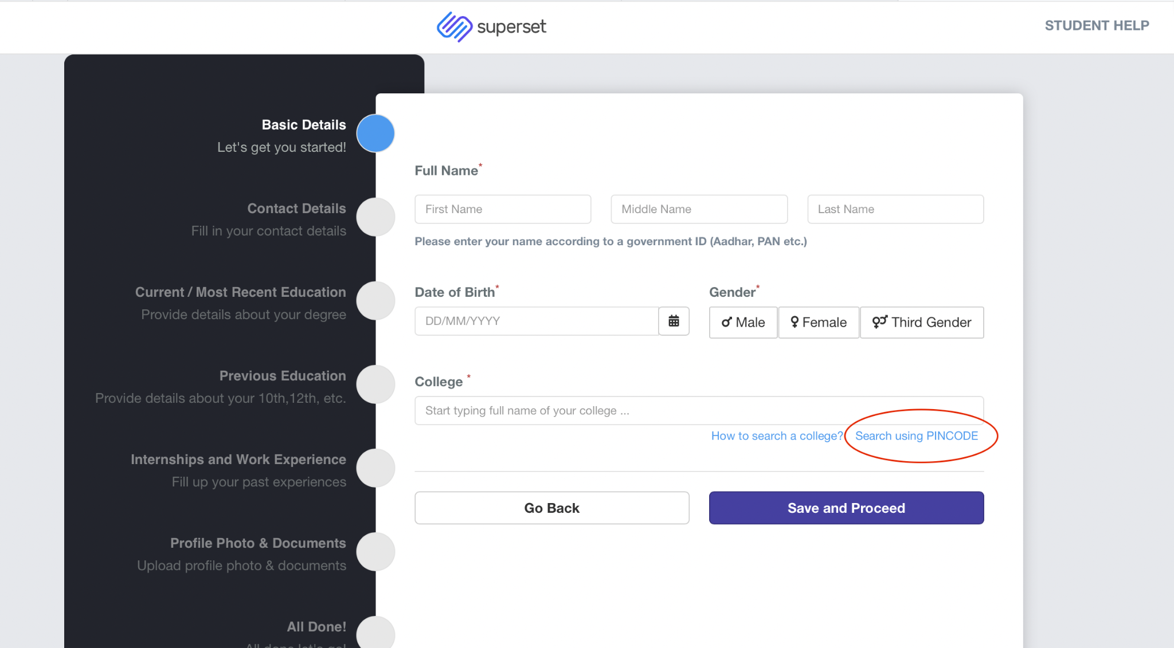
- College (i.e. Ashoka University). If the university fails to come up when typing the name manually, click on the Search with PINCODE button right below the textbox and enter the Ashoka University pincode (131029).

- Enter your Ashoka Enrollment ID number in the Institute Enrollment Number textbox.

- Now, enter your Ashoka Email ID in the Primary Email Address field and your personal email in the Personal Email Address field. Click on Save and Proceed to move on to the next section.

5. Contact Details (Video Guide):

- Verify your contact details, i.e. your primary email address, contact number, and personal email address, by clicking on the verify button and entering the OTP sent to your respective email addresses and phone number.

- Kindly make sure that the phone number you enter is your call number. Click on Save and Next to move on to the next section.

6. Current/ Most-Recent Education (Video Guide):

- In the course group, select the Single Degree option.

- In the course section, choose the P.G.D Young India Fellowship Programme from the drop-down list.

- Choose the correct Course Start date and End date in the respective sections.

- Enter your Ashoka Enrollment ID in the Institution Roll Number/ University ID Number/USN section.

- Select the current semester you are in.

- If you do not have any grades yet, tick the 'I don’t have any scores or grades yet' check box and simply click Save and Next.

- If you are a lateral entry(that is, you enrolled into the programme at a later stage), then please tick the ‘I am a lateral entry’ check-box.

- In the Enter Your Percentage section, your CGPA must be converted into a Percentage. To convert your GPA/CGPA into a percentage, multiply the GPA by 25. (GPA*25).

- If you have a backlog, then kindly tick the 'I have backlog(s)' check-box. Now fill in all the relevant details related to the backlog(s) you have.

- Enter the number of ongoing backlogs and the total number of backlogs (cleared and ongoing ) in the relevant sections. Kindly refer to the video for more clarity. Click on the Save and Next button.

7. Previous Education (Video Guide):
This section will provide information regarding the previous education of the YIFs, encompassing their undergraduate degrees and diplomas, as well as their grades for the 12th and 10th standards. All grades are to be presented solely as percentages; therefore, it is imperative to comprehend the board-specific computation and grade conversion requirements.
The following outlines the board-specific computation requirements for percentages to be recorded in the academic details:
• CBSE: Average of five subjects for classes 10 and 12.
• ICSE: Average of six subjects.
• ISC: Average of five subjects.
• Cambridge Examinations A/AS Level or IGCSE: All marks entered on the Superset portal must be converted into percentages, as direct grades are not permissible. There are two scenarios for conversion:
A: If you possess percentage uniform marks (PUM), simply sum your PUMs and then divide by the number of subjects.
B: If you do not possess PUMs, which indicates that you have teacher-assessed grades, please utilise the attached conversion sheet from the official website.
Kindly refer to the following guides to assist you with your grade conversion:
- IB Grade Conversion
- Cambridge Board Grade Conversions
- PlaceCom_Superset Verification Guidelines

Please Note:

This is the official grade conversion method followed by the university. Any other method will be considered INVALID.
- Fill in all the necessary details related to your class 12th and 10th scores, school, and the start and end dates.

- Click on the Add Another Previous Education option to fill in your Undergraduate degree/diploma details. Once completed, click on the Save and Next button.

8. Internship/ Work Experience (Video Guide):

- Please add details related to all your previous work experiences and internships in this section.

- If you don’t have any work experience/ internships, please tick the I have not completed any internships and I do not have any work experience check-box.
9. Profile Photo:
- Upload a professional headshot for your profile picture. Unprofessional and/or unclear pictures leave a bad impression on the recruiters. Kindly follow the Superset guidelines to know which profile picture works best.
Your registration is now complete!
_______________________________________________________

2. Navigating the Superset Profile and Uploads
Once you log into Superset, you're taken to the dashboard/homepage. This is where you can:
- See notifications from the Career Services or Placement Cell.
- Track ongoing or upcoming applications.
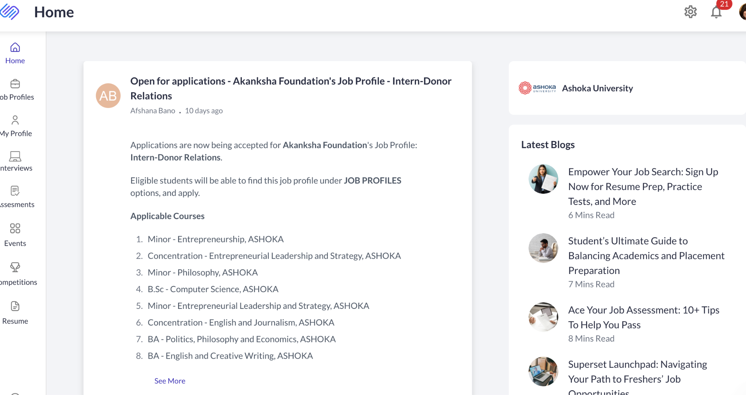
- Access all tabs like Home, Job Profiles, My Profile, etc.
Homescreen
3. Completing the My Profile Section – Mandatory and Extremely Important
Completing the My Profile section is essential for profile verification. You cannot participate in the Placement Cycle without a verified profile. Please upload all necessary documents, including your Class 12th and 10th marksheets and certificates.
Accepted Format: Only PDFs
Steps involved:
- Navigate to “My Profile” on the left-hand menu.
- Click on “Basic Details” and add all relevant information, including summary, social media accounts, profiles, etc.
- Go ahead and explore all the sections below “Basic Details” (e.g., education details, internship and work experience, etc.).
- Click on the “+ add new” button to add any relevant information.
- Do not forget to upload the necessary documents in order to facilitate verification of your profile. These include marksheets, transcripts, certificates and Letters of recommendation.
Please Note:
Screenshots are not considered legitimate proof for internship roles or any other form of certifications or experiences that one has mentioned in their profile. Only legitimate PDF proofs will be considered for verification. Please refer to the PlaceCom_Superset Verification Guidelinesfor further clarity.
- Click on Upload Document, select your PDF, and confirm.
- Wait for the green checkmark or "Uploaded Successfully" message.

3. How to Convert Common File Types to PDF
If your files are in a different format (like Word or JPG), use the following steps to convert them:

Word to PDF:
- MS Word: Open the file → Click File > Save As > Choose PDF.
- Google Docs: File > Download > PDF Document.

JPG/Image to PDF:
- Windows: Right-click the image > Print > Choose Microsoft Print to PDF.
- Online Tools: Use trusted websites like ilovepdf.com or smallpdf.com.
- Phone Users: On iPhone or Android, go to Print > Save as PDF from the photo gallery or a PDF app.

5. Pro Tips
- Name your files clearly (e.g., YashasviGupta_Resume.pdf).
- Keep file sizes below the platform’s limit (usually 2MB–5MB).
- Double-check your uploaded docs for clarity and formatting.
If you face any errors while uploading, try compressing the PDF or renaming the file, and make sure there are no special characters in the file name.
3. How to generate your Superset Resume
- Navigate your “Profile” or “Dashboard” on the Superset Platform.

- Click on the “Resume” option. You will be redirected to a resume builder.

- Click on the “Add Resume” option at the top right.

- Enter “Your Resume Name” and select your most recent resume.

- Finally, click on the “Start Building Your Resume” option to proceed.

- Kindly refer to the PlaceCom_Resume Guidelines.pdf .

- From the left-hand menu, you may modify the font size, format, etc.

- Once finalized, proceed to the “Download as PDF” and “Link to Your Profile” options available on the left-hand menu.

- Please ensure that your resume is no longer than one page.

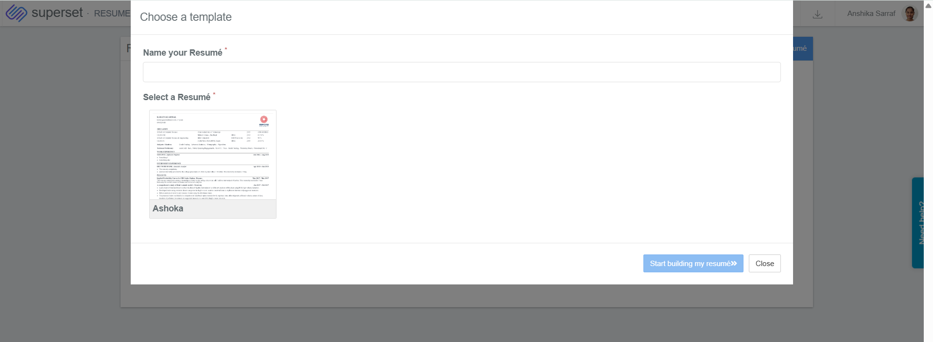
Please Note:
Once the generated resume has been linked to your profile, you may send your profile for verification and enrol in the Placement Cycle via Duperset. Duperset is a tool developed by the PlaceCom Project Team to streamline and efficiently manage profile verification processes. How to get your profile verified.pdf will help you understand how to navigate the verification process and Duperset seamlessly.

YIF Placements

Placements at Ashoka? 2
What is CPP? 3
Career Prep Program (CPP): 3 Mandatory Components: 4
Step 1: Update Superset profile & Send in your verification request via Duperset 4
Step 2: Enroll to Expert Resume Session 4
1. Post-verification, enroll in dummy placements cycle 4
2. Post enrolling in dummy cycle, apply for Resume Review: Mandatory Step (Set 1) 5
3. Post applying for Resume Review: Mandatory Step (any set), Sign up for Expert Slot 6
Once you apply for resume review on Superset, you’ll receive access to a Google Sheet containing time slots with external experts. These are professionals you can meet with to review and refine your resume. 6
Missed Sessions Policy 6
Post-Session Feedback 6
Step 3: Sign-Up for Expert Interview Session 6
Student Tracker 7
Career Prep Program (CPP): Non-Mandatory Components 8
Group Sessions with CDO 8
One-on-One Sessions with CDO Experts 8
CPP Calendar & Non-Mandatory Session Schedule 8
What is Day 0 in Campus Placements? 9
1. Resume Preparation 9
Resume Building Resources 9
A. Resume Repository 9
B. Master & Variant Resume Templates 9
C. PlaceCom Resume Prompt Sheet 9
D. Office Hours with PlaceCom 10
2. Profile Verification on Superset 10
3. Application to Companies 10
4. Shortlisting and Pre-Day 0 Rounds 10
5. Day 0 10
Interview Preparation Resources for Day 0 10
A. Interview Preparation Sheet 11
B. Mentor-Mentee Program 11
What Happens After Day 0? 12
Important Resources 12
● Placement History & Company Data: 12
● Placement Policy 2025–26: 12
● MasterDrive (One-Stop Solution) 12
Frequently Asked Questions (FAQs) 13

Placements at Ashoka?

The Career Development Office (CDO) and PlaceCom will kick off the placement season by circulating a mandatory registration form. This form helps us gather important information such as:
- Your dream companies
- Preparation needs
- Targeted sectors, and more.
This data helps us plan effective outreach and design support tailored to your goals. Most importantly, it allows us to begin with the Career Prep Program (CPP) — the first step in the placement process, focused entirely on equipping you for the upcoming season.

What is CPP?

Career Prep Program (CPP): 3 Mandatory Components:

Step 1: Update Superset profile & Send in your verification request via Duperset
Follow the Superset Verifications Guide: PlaceCom_Superset Verification Guidelines

- Make all edits to your profile and follow the basic resume guidelines.
- Make sure your passout batch is 2026 on Superset.

Step 2: Enrol in Expert Resume Session
Enrolling in the expert resume session also has 3 further steps: -

Post-verification, enroll in dummy placements cycle
Log into your account → go to ‘My Profile’ → ‘Basic Details’ → scroll down and you will see ‘Placement Enrollments’ → Click on the enroll button located on the right side of ‘Dummy Placement Cycle 2025-26’.

Once you enroll, you will see screen as shown below:

Post enrolling in dummy cycle, apply for Resume Review: Mandatory Step
Log into your account → go to ‘Job Profiles’ → ‘Basic Details’ → click on ‘Resume Review: Mandatory Step’ → Click on ‘Apply’ that is on the top right corner of the ‘Resume Review: Mandatory Step’ Job Profile.

Please note: Only Set 3 is open for YIF students for the ‘Resume Review: Mandatory Step’. As given below: -

Set | Start-End Date | Eligible
Resume Review: Mandatory Step [Set 3] | 15th - 31st August 2025 | Ashoka Fellows graduating in 2026 ONLY!

Post applying for Resume Review: Mandatory Step, Sign up for Expert Slot

Once you apply for resume review on Superset [Set 3], you’ll receive access to a Google Sheet containing time slots with external experts. These are professionals you can meet with to review and refine your resume.
Weekly Slot Timings
- New slots open every Wednesday at 4:00 PM. Please check your emails every now and then.
- Sign-up closes by Thursday EOD
- You will receive a reminder email 2–3 hours before your chosen slot on your registered email ID
Submitting the Right Resume
Some of you may have uploaded an older version of your resume while registering on Superset. If that’s the case, don’t worry; you can upload a new or updated resume while signing up for the office hour slot. Please ensure that your resume is no longer than a page.

Please ensure:
- Your resume follows Superset guidelines
- You generate it via Superset > Resume Builder
- No re-verification is needed for this updated resume
- Just download the new version and paste the link in the Google Sheet when signing up

Missed Sessions Policy
If you miss your scheduled session or fail to show up:
- Your ID will be blocked for 2 weeks
- You will not be allowed to book any resume review sessions during this period

Post-Session Feedback
After your expert session, you’ll receive a feedback form. Kindly fill it out; it helps us improve future sessions and offerings.

Guidelines to Fill the Expert Resume Sign-up Sheet

COLUMN | What to Fill | Notes
F (MANDATORY)  IMP: Used for sending session reminders. | Your Name (Name Chip) | Click on the name smart chip, start typing your name (your Ashoka email should pop up).  Do not manually type your name or email ID.
G (MANDATORY) | Batch | This will be auto-filled once the name chip is selected correctly.
H (MANDATORY) | Phone Numbers | Required for quick communication.
I (MANDATORY) | Major | Enter your declared major.
J (Suggested) | Student Expectations | Share any specific areas you want feedback on (e.g., formatting, content, role/sector-specific, etc.).
O  (IMP MANDATORY) | Latest Resume | Upload your latest resume to your Ashoka Google Drive.  Please ensure that you give the PDF files access to @priyanka.laishram@mbatrek.com, connect.cdo@ashoka.edu.in & connect.placecom@ashoka.edu.in

Step 3: Sign-Up for Expert Interview Session
Once the resume reviews are complete, you will get a sign-up Google Sheet for an expert interview session. Once you complete that, all mandatory steps for CPP are completed.

Student Tracker
  - You can also verify your enrolment by finding your name on this sheet. Use this sheet to track your progress across all mandatory steps for the CPP (Career Preparation Programme): (YIF student Tracker).

*Please note: This tracker gets updated every Sunday EOD, after all weekly expert resume sessions conclude.

Important Timelines
👉 Click here to access the YIF Townhall PPT

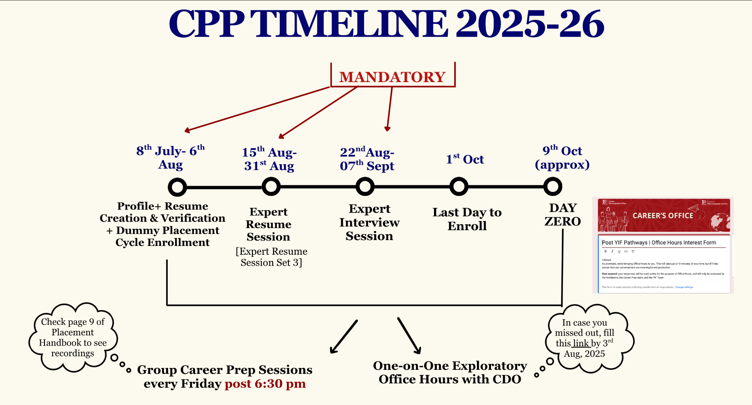

Career Prep Program (CPP): Non-Mandatory Components
While CPP has 3 mandatory steps [1. Update Superset Profile and Verify, 2. Expert Resume Session, 3. Mock-Interview Session], there are also several non-mandatory but highly recommended components designed to support your preparation further.

Group Sessions with CDO
- Held every Friday at 6:30 PM
- Conducted by CDO experts on various placement prep topics
- All sessions are recorded and accessible via this folder: CPP Session Recordings-Pre Day 0
- Strongly recommended to watch all recordings — they provide valuable preparation insights!

One-on-One Sessions with CDO Experts
If you'd like personalised guidance, you can also schedule 1-on-1 sessions with CDO experts.
How to Book a Slot:
- Log in to AMS
- Go to Student Support → Advising Hub: Office Hours
- From the drop-down, choose Career Prep Program
- Select a date and time that works for you
- Your slot will be auto-added to your calendar
A few quick notes:
- These Office Hours are distinct from the Career Development Program and Postgraduate Office sessions on AMS
- They are not part of the mandatory resume review or mock interviews required for placement enrollment.
- Attendance is not mandatory—but highly encouraged!

CPP Calendar & Non-Mandatory Session Schedule
To view the full CPP calendar, including upcoming group sessions and other events, check this link: CPP Calendar_2025-26.xlsx

What is Day 0 in Campus Placements?
Once CPP is completed, the placement process unfolds in multiple stages, and Day 0 is a key and 1st milestone. Let’s walk through it from the beginning assuming that company X comes for hiring:

1. Resume Preparation
Before applying to any company, you must create a tailored resume. Ensure that your resume is no longer than one page and generated via Superset. Use the resources below to guide your process:

Resume Building Resources
Kickstart your placement prep with these essential resources to help you craft an impactful resume. These tools will help you understand formatting and content and how to tailor your resume to different roles and industries.

Resume Repository
- Explore resumes of previously placed students across sectors like consulting, finance, social impact, and more. Use these as reference points while crafting your own resume.
- Link to Resume Repository: PlaceCom_Resume Repository

Master & Variant Resume Templates
- Use these to structure your own résumé according to the CDO guidelines.
Includes:
- Master Resume Template: General template used across sectors
- Variant Resume Examples: Sample customisations for different job profiles
- Link to the Template: PlaceCom_Master VS Variant Resume Making.pdf

PlaceCom Resume Prompt Sheet
- A guided worksheet to help you brainstorm and articulate your achievements, responsibilities, and impact across internships, projects, and leadership roles.
- Link to the prompt sheet: PlaceCom_Prompt Sheet

Office Hours with PlaceCom
- Book a 15-minute one-on-one slot with a PlaceCom member to get feedback on your draft before submitting to expert sessions.
- Link for booking a session: PlaceCom_Office Hours

2. Profile Verification on Superset
Once your resume is ready, submit it and get your profile verified via Duperset.

3. Application to Companies
Apply to company-specific job profiles using the variant resume tailored for that role on Superset by submitting your resume & other details required.

4. Shortlisting and Pre-Day 0 Rounds
If shortlisted:
- You may be invited for technical tests, aptitude rounds, or interviews (this varies by company).
- Some rounds might be online, monitored, or timed submissions.
- These preliminary rounds typically happen before Day 0 — in late August or early September.

5. Day 0
Day 0 refers to a designated 2-day window when marquee firms (top recruiters across sectors) conduct their final interview rounds, often on campus.
- Usually scheduled for the end of September or start of October.
- If selected, you’ll know your result on the same day.
- This marks the conclusion of the initial hiring phase.

Interview Preparation Resources for Day 0
Prepare confidently for your interviews with curated, insider-led resources. These tools feature real questions asked by recruiters and tips shared by selected students to help you build confidence and clarity.

Interview Preparation Sheet
  - Contains actual interview questions asked by recruiters from companies such as BCG, Accenture, Deloitte, DE Shaw, TCF, etc. A great resource to understand what recruiters look for and tailor your prep accordingly.
  - Link to Interview Prep Sheet: PlaceCom_Interview Preparation Sheet'25

Mentor-Mentee Program
  - Navigating academics and career choices can be challenging—but you don’t have to do it alone.
  - This initiative pairs current students with recent Ashoka alumni working at top firms like BCG, EY, Deloitte, Dalberg, and more. We will be offering one-on-one mentorship to help you explore career options, seek advice on placements/internships, and gain professional insights.
  - Link to Mentor-Mentee Program sign-up sheet: Application Form. This is phase 1 of the program, we will be having multiple phases with more mentors soon!

What Happens After Day 0?
- The process moves into Phase 1, then Phase 2, and Phase 3 — each bringing new companies to campus.
- These phases do not indicate any hierarchy; they exist for administrative ease and scheduling.
- Please note that all students are eligible to apply to one dream company regardless if they have received an offer already. However, students must accept offers from phase one companies if they do not receive an offer from their dream company. In this case, rejecting a phase one offer could lead to unenrollment from the placement cycle.

Important Resources

Placement History & Company Data:
Past company data is available here Past Recruiters Data & Analysis .

Placement Policy 2025–26:
Details about number of attempts, company eligibility, and process rules is here Policy 2025-26

MasterDrive (One-Stop Solution)
A centralised repository of all official placement documents, policies, templates, and support material. Here is the link to MasterDrive: Master Resource Drive 2025

Frequently Asked Questions (FAQs)
Q: Can I make changes to my profile after it has been verified?
A: Yes, you can make changes. However, you must send a new verification request each time you update your profile.

Q: How do I send a verification request again (2nd time or more)?
A: Use Duperset every time you need to send a verification request.

Q: What is Duperset?
A: Duperset is a tool developed by the PlaceCom Projects team to streamline and manage the profile verification process efficiently. Check it out here

Q: How long does profile verification take?
A: It typically takes up to 48 hours for your profile to be verified by your Point of Contact (PoC).

Q: Can I book another resume slot with an expert to improve my resume further?
A: Yes, but only after everyone in your set has completed their first session. We prioritize students who haven’t had a chance yet before allowing repeat slots.

Q: I'm unable to apply for the dummy placement cycle. What could be the issue?
A: Please ensure the following:
- You are enrolled in the placement cycle
- You are part of the Passout Batch 2026
- Your profile is verified on Superset
Q: I have verified my profile. Can I still add things to Superset later?
A:Yes. You can add more details like new internships, certifications, etc., even after verification. However, every new addition will require fresh verification with proper PDF proof.

Q: I’m not able to enrol in the Dummy Placement Cycle. What should I do?
A: Please follow these steps:

Step A: Ensure profile verification:
•⁠ ⁠Edit all details and attach PDF proof
• Using this, submit your profile for verification: How to get your profile verified.pdf
Submit request via [Duperset]: https://www.instagram.com/p/DLFhJ3SB_PX/?igsh=aHNvZjhuOGJyYThj
OR
⁠Submit request via [Website]: https://ashokaplacecom.github.io/verify.html

Step B: The education section must reflect:
•⁠ ⁠‘2026 Passout Batch’ under Batch
•⁠ ⁠Course End Date: May 2026

If not editable, post on the PlaceCom Chatroom with your enrolment ID and your issue.

Step C: Once the above are done, go to Basic Details on Superset and enroll in ‘Dummy Placement Cycle 2025-26’.

Q: My verification was approved, but it still shows pending. What should I do?
A: Resubmit the verification request via Duperset or the website. If it still doesn’t update after 48 hours, post on the PlaceCom Chatroom with your Enrollment ID.

Q: How do I get in touch with my PoC?
A: The PoC system is anonymous. You cannot contact them directly. Instead:
• Submit verification using Duperset or the website.
•⁠ ⁠If you need help, post on the Chatroom or email Connect Placecom.

Q: What proof is accepted for clubs and societies?
A: Any one of the following:
•⁠ Certificate or letter of appointment
•⁠ ⁠Screenshot of official email
•⁠ ⁠Screenshot from official club social media
•⁠ ⁠WhatsApp group screenshot (if created by official authority)

Upload as a PDF on Superset. Screenshots too must be converted into PDFs.

Q: I’m not receiving an OTP on the verification website. What should I do?
A: Try incognito mode or switch to the Duperset extension. If still unresolved, email Connect Placecom or post in the chatroom.

Q: Can third-year students (5th semester) sit for placements?
A: No. As per the updated policy, 5th-semester students in 4-year UG programmes cannot sit for placements. Email the CDO and cc Connect Placecomif you’d like to discuss.

Q: Where can I find the CPP session calendar?
A: Refer to this link: CPP Schedule 2025–26 → CPP Calendar_2025-26.xlsx

Q: How can I see companies that came last year?
A: Check the Past Recruiters section in the MasterDrive (link in the group description). Phase-wise data is listed there.

Q: What to do if my resume was wrongly rejected for personal pronouns?
A: Recheck for “I”, “my”, “we” and remove if missed. Then resubmit your one-page resume via Superset. Refer to the official PlaceCom_Resume Guidelines.pdffor clarity.

Check YIF Progress

Disclaimer
Please carefully review the next steps based on where you currently are in the placement process. Kindly follow the instructions relevant to your category:

Type 1: Completed till Resume Review
(Profile got verified → Enrolled in Dummy Cycle → Applied for Expert Resume Session Set 1 → Booked & Attended Resume Review Slot)
Next Steps:
- (Optional) Attend an additional resume review for deeper feedback (if needed).
- (Mandatory) Attend the interview preparation slot – rollout will begin next week.
- You’re all set!

Type 2: Removed From Booked Slot
(Profile got verified → Enrolled in Dummy Cycle → Applied for Expert Resume Session Set 1 → Booked Resume Review Slot → Slot Cancelled because you submitted resume that violated basic guidelines)
Next Steps:
- Re-submit your resume correctly
- Fill the slot sheet again using the correct resume format & upload your resume on the slot sheet itself
- Ensure your resume meets all formatting and content guidelines
- The slot sheet will be shared every Wednesday at 4 PM
⚠️ Note: If your resume does not meet the requirements again, your name will be removed once more, so please follow all guidelines carefully.
- (Optional) Attend an additional resume review for deeper feedback (if needed).
- (Mandatory) Attend the interview preparation slot – rollout will begin next week.
- You’re all set!

Type 3: Completed till Expert Resume Session
(Profile got verified → Enrolled in Dummy Cycle → Applied for Expert Resume Session Set 1)
Next Steps:
- Book a resume review slot from the sheet shared every Wednesday at 4 PM.
- Attend the slot and update your resume accordingly.
- (Optional) Attend an additional resume review if you want more feedback.
- (Mandatory) Attend the interview preparation slot – rollout will begin next week.
- You’re all set!

Type 4: Only Enrolled in Dummy Cycle
(Profile got verified → Enrolled in Dummy Cycle)
Next Steps:
- Wait until the 18th of July, when Resume Session Set 2 will open.
- Apply on Superset for Set 2 once announced.
- Book a resume review slot from the sheet shared every Wednesday at 4 PM.
- Attend the slot and update your resume accordingly.
- (Optional) Attend another resume review for further refinement.
- (Mandatory) Attend the interview preparation slot – rollout will begin next week.
- You’re all set!

Type 5: Did Not Enroll in Dummy Cycle
If you did not enroll in the dummy cycle, please email us at connect.placecom@ashoka.edu.in explaining your situation. We’ll evaluate your case individually and guide you to move into Type 4.
You can refer to this video to learn how to check whether you're enrolled in the dummy cycle, Expert Resume Session Set 1, and other components.

